Shivraj PABSON
First Terminal Examination 2081
Time: 3hrs F:M=75
Class:- 9 Sub:- O.P.T - Maths P:M=
Attempts all the questions:
Group A [5x2=10]
1. a) Defind ordered pair with an example .
b) If (x+2,4)=(6,4) what is the value of a ?
2.a) If AxB = {(a,1) , (a,2) , (b,1), (b,2) } list out the element of set A.
b) Define function .
3.a) From the given figure , find the co-domain of the function f.

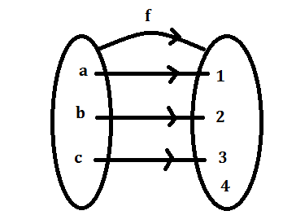

b) Find the figure degree of the polynomial
9$x^{5}$ - 4$x^{3}$ +3$x^{2}$ -7$x+15$
4.a) Define sequence with an example .
b) Find the next term of the sequence x, -$x^{2}$,$x^{3}$,-$x^{4}$,……
5.a) Find the limit of the sequence 02.,0.02,0.002,0.0002……..
b) Find the 8th term of the sequence 1.9,1.99,1.999……..
Group B (4x4=16)
6.a) for what values of p and q , (2p-7,4q-8) and (p+8,2q+4) are equal to each other.
b) If A= {1,2,3} and B={ a,b,c} find AxB .
7.a) If the function f(x) =8x-9 and domain D={4,5} , Find its range .
b) If f(x) = 2$x^{3}-7$ find the value of f(-2) .
8.a) If p(x) = (a-2) $x^{2}+$ (b+1) x+ (c+2) , q(x) = 5$x^{2}+6x+8 and p\left(x\right)=q\left(x\right)$ Find the values of a and b.
b) If p(x) =3$x^{3}+2x^{2}-5$ and q(x) = 2$x^{3}-3x^{2}+7x+7,$ find the sum of p(x) and q(x) .
9.a) If f(x) =2$x^{3}-4x+5 and g\left(x\right)=2x^{2}-2x+3$ Find the product of f(x) and g(x) .
b) Find the 15 term of the sequence 3,6,9,12……………
Group c 11x3=33
10. If A= {p,q} and B= {2,4,6} find AxB and BxA by mapping diagram.
11. If P= {$x:6≤x≤8\} and Q=\{ x:2<x≤4\}$ Find PxQ.
12. Write the difference between relation and function.
13. If f(x) =2$x^{2}-4x+5$ find the value of f(7) + f(9) .
14. If f(x) =2x-5 show that $\frac{f\left(x+h\right)-f\left(x\right)}{h}$ =2
15. if P(x) = 11$x^{2}-5x+7, q\left(x\right)=13x^{2}+5x-9 and r\left(x\right)=3x^{2}-6x+1$ then find p(x) +q(x) -r(x) .
16. Find the quotient and remainder of the following condition p(x) $÷$q(x) where p(x) =8$x^{3}$+2$x^{2}-6x+5 and q\left(x\right)=x-2$
17. A sequence of number is given as 6,11,18,38…….find ,
i) nth term
ii) next two terms
iii) value of 11th terms
18. Find the sum of $\sum_{n=2}^{9}{\left(2n^{2}-n+5\right)}$
19. if the function f(x) = $\frac{x^{2}-4}{x-2}$
i) Find the values of f(x) at x=1.9, 1.09,1.009
ii) Find the values of f(x) at x=2.01, 2.0011
iii) What is the limit value of the function f(x) .
20. Each side of an equilateral triangle is 100cm . A second equilateral triangle is inscribed by joining the mid -points of the sides successively. This process is continued infinitely many times.
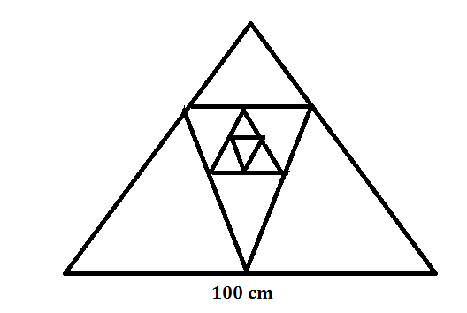
a) Find the length of 3rd sides .
b) What is the limit of area of
triangle ?

c) What is the limit of perimeter of triangle ?
Group D 4x4=16
21. If f(x) =2x+3; R= {5,7,9} Find its domain and represent the function in
a) Tabular form b) Mapping diagram
22. If f(x+2) = f(x) +f(2) then prove that : f(0) =0 and f(-2) =-f(2)
23. if f(x)= ax+b,f(-3) =-4 and f(3) =2 , find the values of a and b.
24. If f(x) =$\frac{2}{5}$ - $\frac{1}{2}x+\frac{8}{9} x^{2}-\frac{4}{5} x^{3},g\left(x\right)=\frac{1}{3} x^{3}-\frac{1}{3} x^{2}+\frac{3}{4} x-\frac{8 }{5} and h\left(x\right)=\frac{5}{9} x^{2}+\frac{1}{4} x-\frac{6}{5}$ - $\frac{7}{15 }$ $x^{3}$ then prove that f(x) +g(x) -h(x) is zero polynomial .
The End

